**Deliverable task-**

* Create a virtual network with 2 subnets. Each subnet should have 16 Ips only.
* Inside one of the subnets, create a VM and deploy an application code inside it (any existing application created by you before). Make sure to use appropriate NACLs and SGs.
* Deploy the same application to Elastic beanstalk Service.
* Create a Lambda that should trigger as soon as you upload a file in the S3 bucket.
* Function should be able to print the name of the file uploaded in the function.

1- Create a virtual network with 2 subnets. Each subnet should have 16 Ips

First we go to AWS VPC

VPC with 2 subnets created successfully.

2- Inside one of the subnets, create a VM and deploy an application code inside it .Make sure to use appropriate NACLs and SGs.

First create a VPC with name my-vpc

Then create a subnet in it

Subnet is created successfully with name my-subnet.

Then go to Gateway and create it WITH NAME MY-INTERNET-GATEWAY-1

Then attach it to our VPC.

My-internet-gateway created successfully.

Then go to route Table and create it with table name my-route-table-1

Route table is created successfully.

Then go to edit the route and add destination 0.0.0.0/0 and attach the internet gateway.

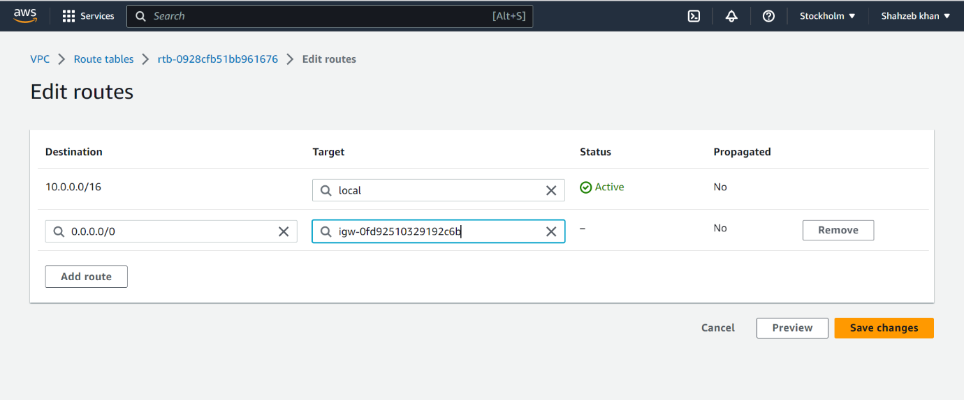

Then attach the subnet with route table.

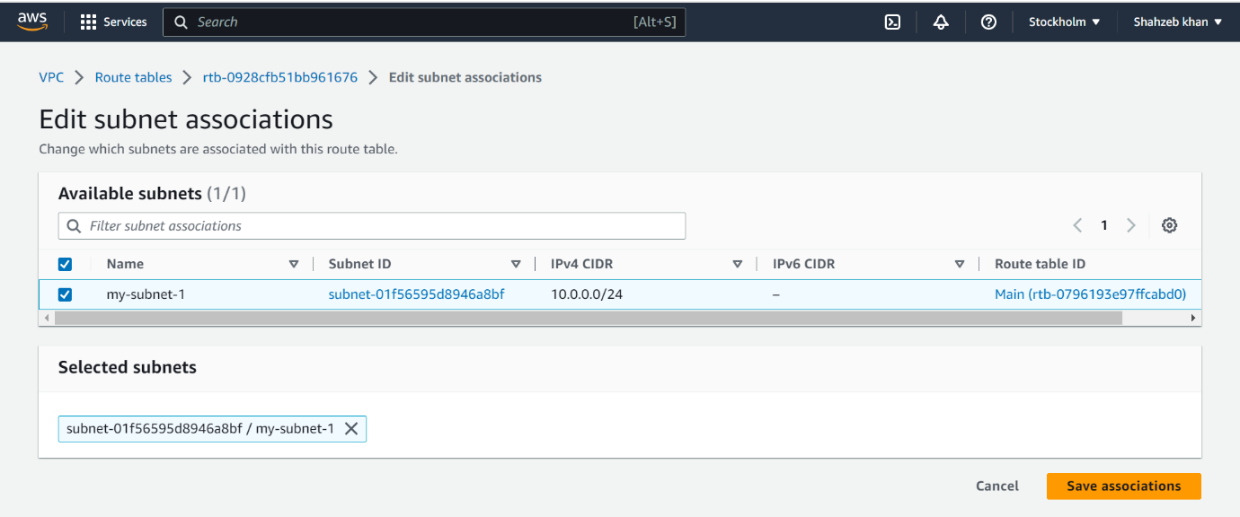

Then create a E2C instance then choose a Microsoft Windows server and configure the instance with 2 GB

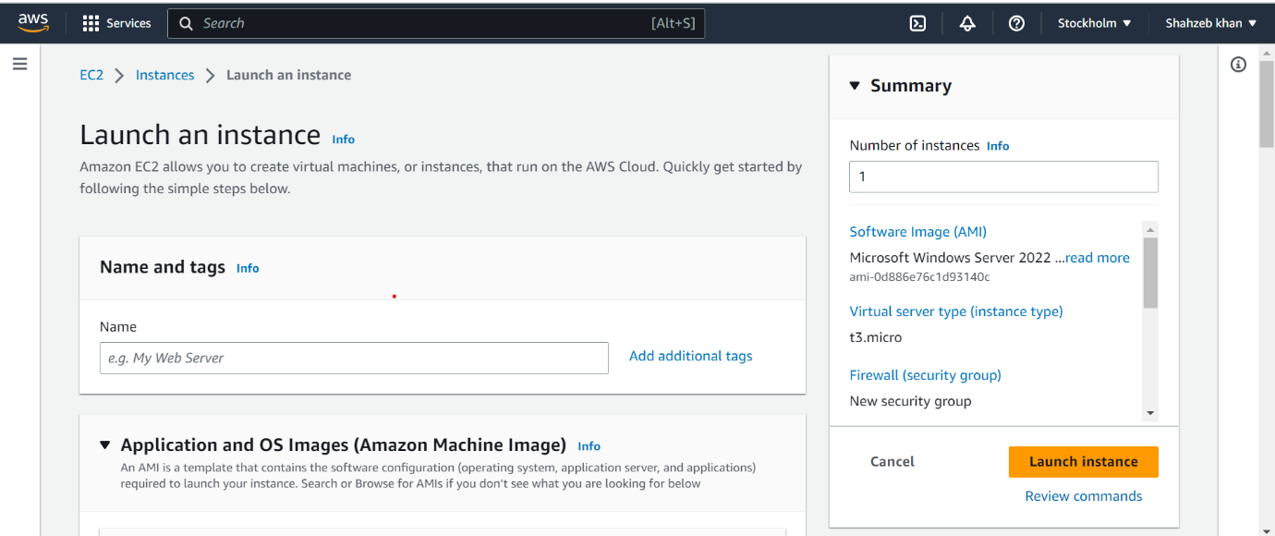

Then Create kay pair with name MyKeyPair and select RSA in this then create it .

Then E2C instance is created then select this instance and connect it .

Then go to RDP Client and get password.

Then copy this password and paste it in key value pair download remote desktop file and open these pastes the password and connect it .

E2C Instance is created successfully.

Then Transfer the project in E2C instance and run this application in E2C instance.

Then paste the URL so our application is successfully deployed in E2C machine .

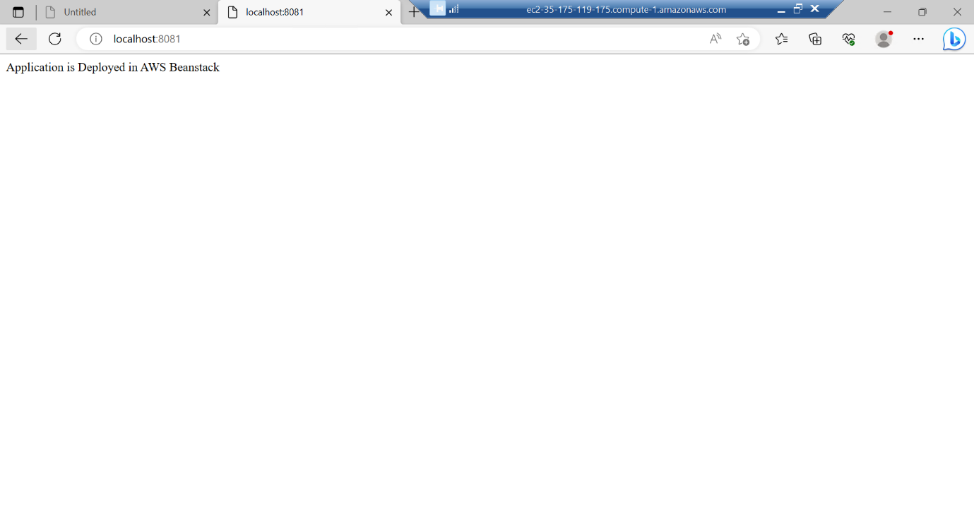

3- Deploy the application to Elastic beanstalk Service

First create a spring boot project with API .Then go to Elastic Beanstalk service . In this select a Web server environment and name spring-application

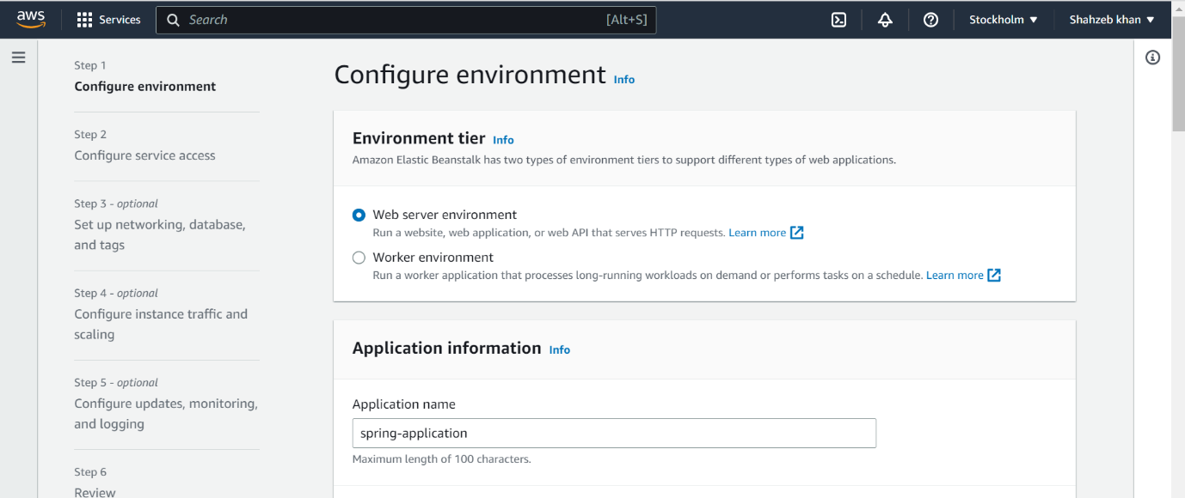

Give platform Java and platform branch Correto 17 then upload a code in this the click on create.

Successfully created

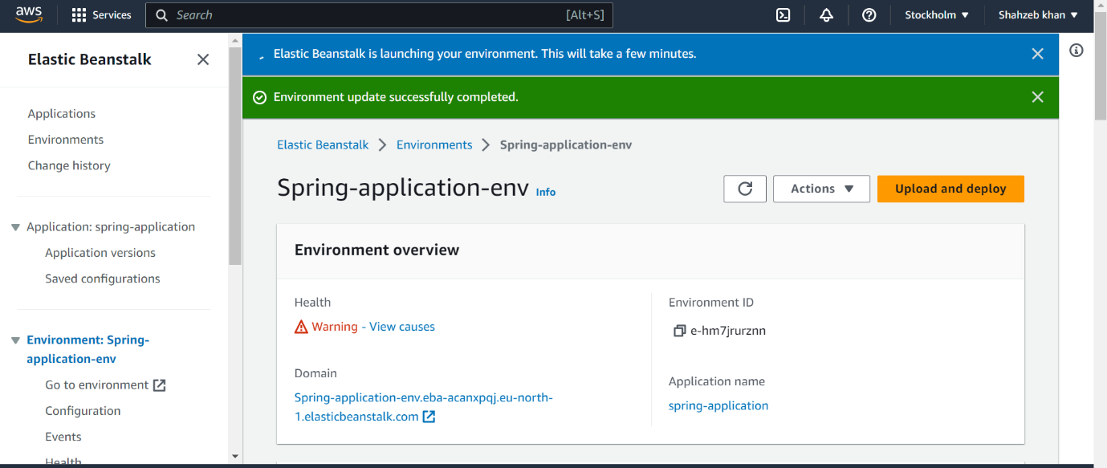

Then copy the URL of domain and open it in window . See the application is successfully deployed and we can see our application here .

4- Create a Lambda that should trigger as soon as you upload a file in the S3 bucket.

Function should be able to print the name of the file uploaded in the function.

First, we must create S3 bucket first so go to bucket in AWS name it with shah-bucker-1.

Then press create button .

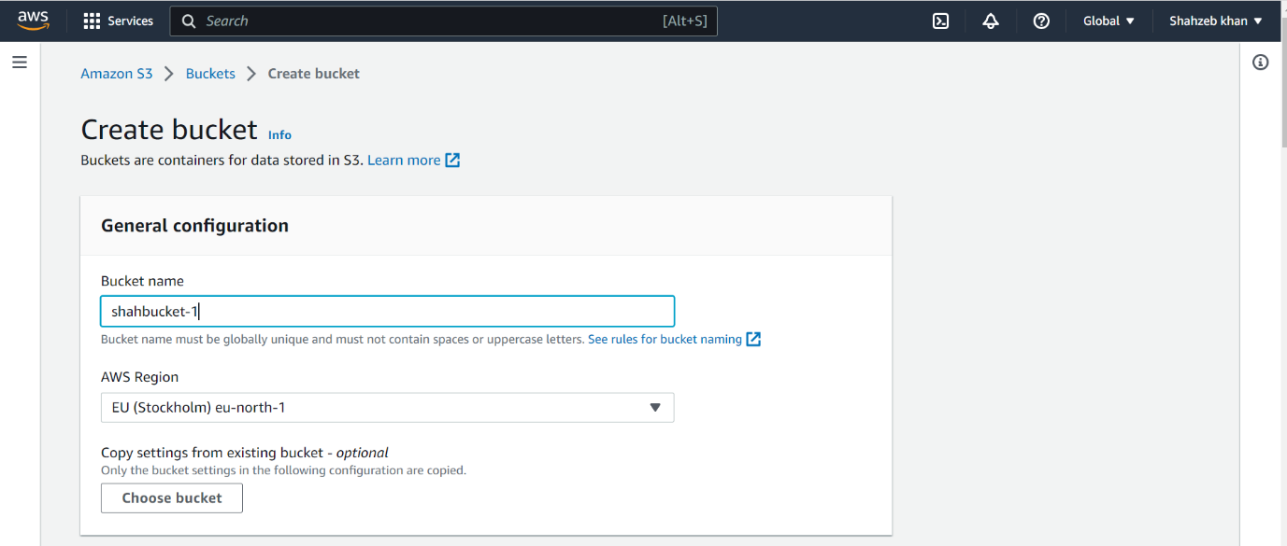

Bucket is created Successfully.

Then create a Lambda function with name shah-lambda-1 choose runtime python

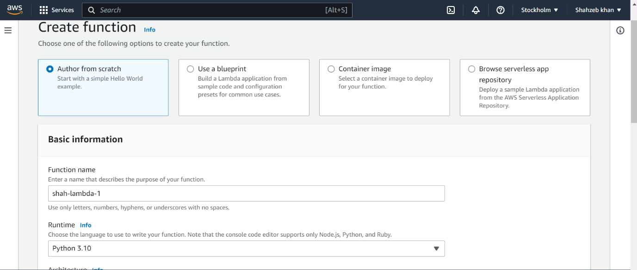

Then in this lambda function create a role shah-role-1 and choose amazon s3 object read only permission.

Then click the create button then lambda function will be created Successfully .

Then go to s3 bucket then select our bucket then go to properties and create a enable Event notifications with name triggerlambda and choose our lambda function here.

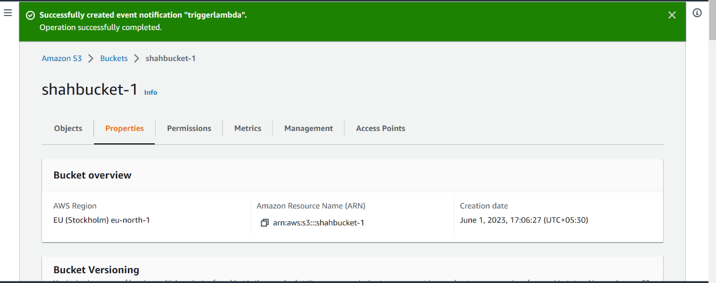

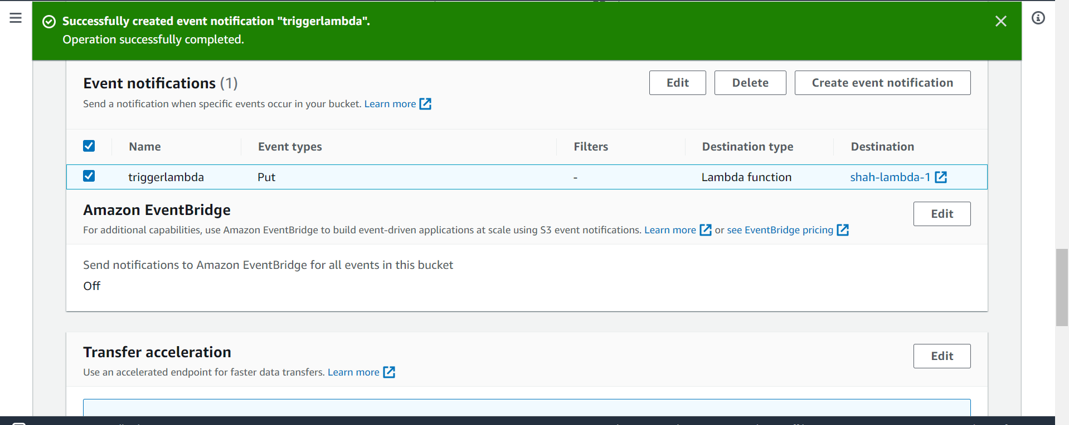

Then go to lambda function and paste a python code for printing the name of a file when file is uploaded.

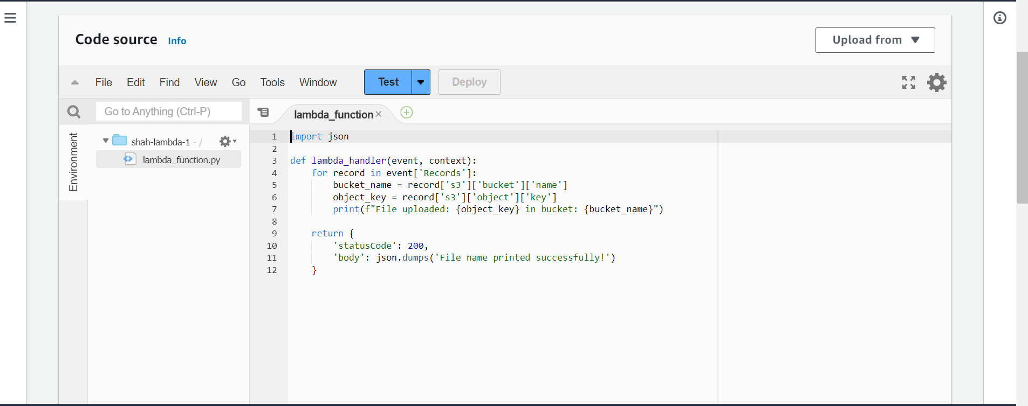

Then go to bucket and upload the file.

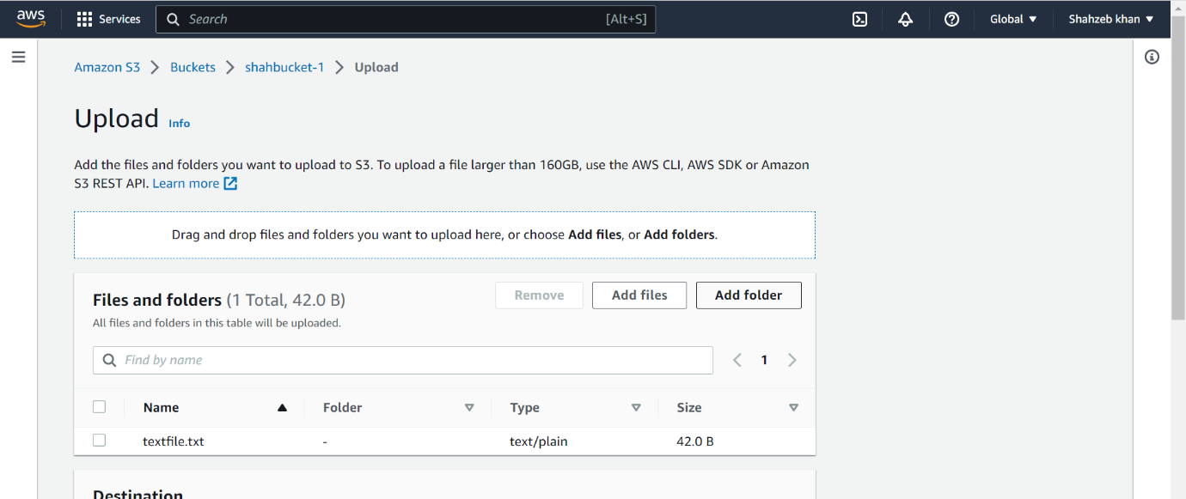

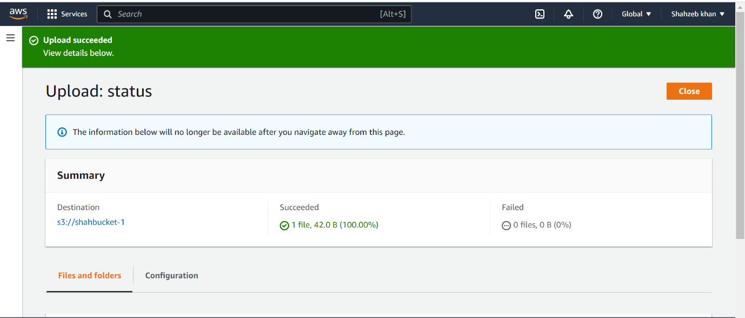

Then go to our lambda function in this go to monitoring and see a logs where all details of file uploaded are here with file name.

